**C:\Documents and Settings\kimberly.geddes\Local Settings\Temporary Internet Files\FrontPageTempDir\MCj03675480000[1].wmfGeddesPhysics**

**Sequoyah High School**

**AP Physics C**

**Rotational Motion Lab**

**Objectives:**

* Measure the translational acceleration of a object falling from a pulley (as illustrated in the figure below), and
* Use the measured acceleration to analyze the validity of assumption that the pulley exhibits rotational inertia consistent with a disk (*I* = ½ MR2).



**Equipment:**

Pulley, hanging mass, motion detector with CBL data acquisition system.

**Background:**

Most rotational motion problems involving an object falling from a pulley advise the solver to assume that the pulley exhibits the rotational inertia of a disk:

$I= \frac{1}{2}MR^{2}$ (1)

 To verify the validity of this assumption, one could measure the translational acceleration of the falling object and relate this acceleration to the angular acceleration of the pulley. After determining the angular acceleration of the pulley, applying Newton’s Second Law for Rotational Motion (equation 2) would yield an empirical value for the rotational inertia of the pulley.

$\text{ = Iα}$ (2)

The torque is provided by the weight of the falling object located a distance R from the axis of rotation of the pulley. Translational acceleration of the falling object can be determined by obtaining distance and time data.

**Experimental Procedure:**

* Measure the mass and the radius of the pulley.
* Measure the mass of the object.
* Set up the motion detector to detect the distance travelled by the falling mass by placing it below the pulley.
* Measure and cut the string so that it is not long enough to allow the mass to hit the motion detector.
* Release the mass and measure the data.
* Change in height = ½ * acceleration * (time)^2
* Change in height = (1/2 * acceleration) * (time)^2
* Plot the change in height vs. (time)^2.
* M = (1/2 * acceleration)
* Acceleration = 2*(slope of the best fit line)
* Relate translational acceleration to angular acceleration.
* Solve for torque.
* Use torque and angular acceleration to solve for moment of inertia.
* Calculate moment of inertia by using the formula.
* Calculate percent error.

**Data:**

|  |  |
| --- | --- |
| Time^2 | distance |
| 0.124 | 0.988186 |
| 0.13 | 0.978191 |
| 0.135 | 0.970416 |
| 0.141 | 0.952368 |
| 0.147 | 0.939874 |
| 0.154 | 0.930989 |
| 0.16 | 0.924047 |
| 0.167 | 0.913774 |
| 0.173 | 0.917661 |
| 0.18 | 0.906555 |
| 0.187 | 0.894893 |
| 0.194 | 0.882676 |
| 0.201 | 0.869904 |
| 0.208 | 0.856299 |
| 0.215 | 0.842416 |
| 0.223 | 0.8277 |
| 0.23 | 0.812151 |
| 0.238 | 0.796324 |
| 0.246 | 0.779943 |
| 0.254 | 0.760507 |
| 0.262 | 0.744958 |
| 0.2704 | 0.726355 |
| 0.279 | 0.707751 |
| 0.287 | 0.688315 |
| 0.296 | 0.668046 |
| 0.305 | 0.6475 |
| 0.314 | 0.625842 |
| 0.323 | 0.604185 |
| 0.332 | 0.584471 |
| 0.341 | 0.561981 |
| 0.35 | 0.53949 |
| 0.36 | 0.519777 |
| 0.369 | 0.495065 |
| 0.38 | 0.470353 |
| 0.389 | 0.42454 |
| 0.399 | 0.400384 |
| 0.42 | 0.354015 |
| 0.43 | 0.340409 |
| 0.44 | 0.318752 |
| 0.452 | 0.285155 |
| 0.473 | 0.226847 |
| 0.484 | 0.198526 |
| 0.496 | 0.170482 |
| 0.507 | 0.15771 |
| 0.518 | 0.12689 |
| 0.53 | 0.126335 |
| 0.542 | 0.129111 |

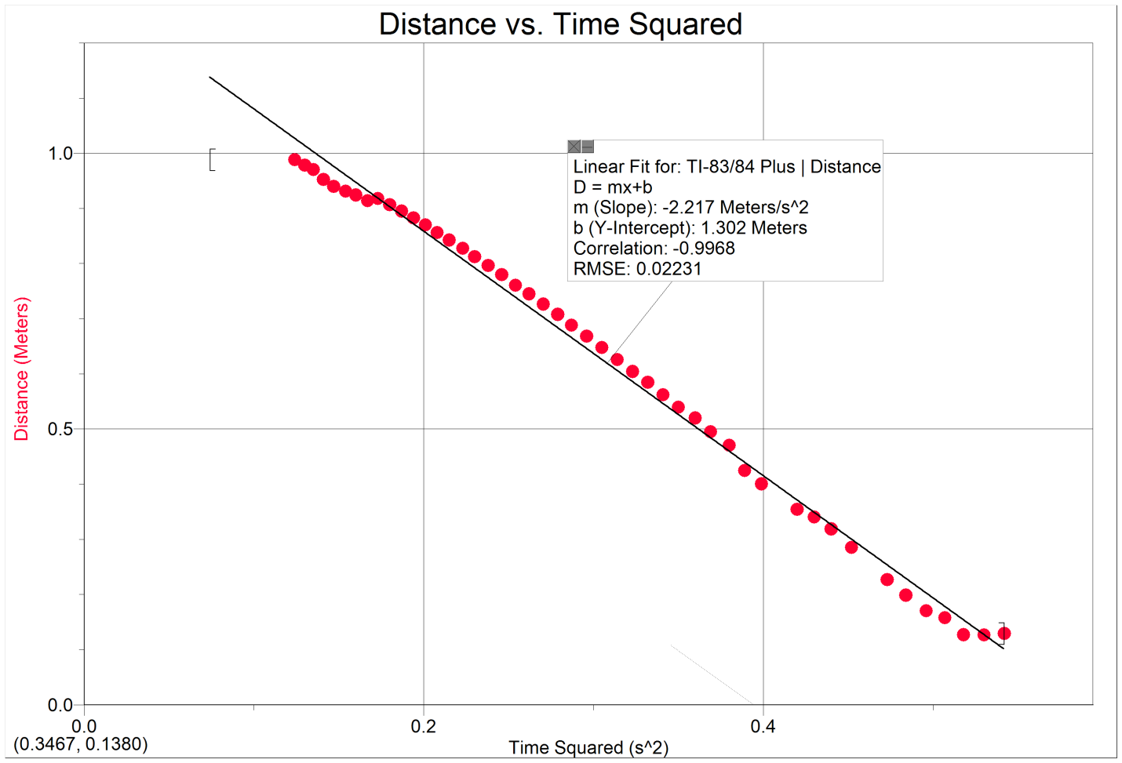

**Data analysis:**

mweight = 100g = .1 kg

mpulley = 12.7g = .0127 kg

rpulley = 17.5 mm = .0175 m

M=-2.217 m/s^2 = ½*a

a = -4.434 m/s^2

a = αr

-4.434/.0175 = α = -253.4 rad/s

τ = Icalculated * α

τ = F x r = mg x r = .1*-9.8*.0175 = -.01715

Icalculated = τ/α = -.01715/-253.4 = 6.768E-5

Iformula = ½ * m * r^2 = ½ * .0127 * .0175^2 = 1.945 E -6

%error = (Iformula - Icalculated)/((Iformula + Icalculated)/2) * 100% = (1.945E-6 – 6.768E-5)/((1.945E-6 + 6.768E-5)/2) * 100% = -188.826%

**Conclusion:**

The percent error obtained was -188.826%. With just this one experiment, it would appear that the formula does not accurately model the moment of inertia. However, this may not be true, as there was considerable room for error. The motion detector did not accurately get all of the points because the weight swung too much, and the detector sometimes picked up static, making our data questionable. We had to delete many bad points to get data that appeared linear, but we may have deleted points that would have yielded a more accurate acceleration. In addition, when calculating the moment of inertia, we had to use a constant radius number. However, the radius was not constant because it got smaller as more string unraveled. More trials might have revealed better data. The idea of the experiment worked. We were able to measure translational acceleration and relate it to angular acceleration. We were also able to calculate the moment of inertia two different ways and compare them. Unfortunately the comparison did not reveal the results that we wanted.